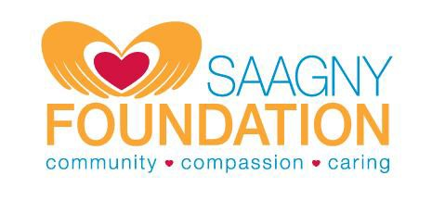

THE SAAGNY FOUNDATION COLLEGE SCHOLARSHIP APPLICATION

The SAAGNY Foundation Scholarship was established to help further the educational goals of SAAGNY member companies’ employees, owners, and immediate family (parent/guardian, child, sibling or spouse) who have been employed in the promotional products industry for at least two years. Since its inception, over $200,000 in scholarships have been awarded. Applicants will be eligible for a scholarship award as full-time (12 credits or more per semester) undergraduate students at any accredited school (Community College, Technical School, Vocational School, 4-year College or University).

Scholarship awards are reviewed by independent judges and based on overall merit with points assigned to:

- Academics and Grade point average
- One academic letter of recommendation
- One non-academic letter of recommendation
- Essay
- Extracurricular activities
- Charitable activities and community service
- Awards and achievements
- Professionalism
- Outside jobs and projects
Scholarships will be awarded without discrimination as to financial need, race, sex, or religion and are awarded in the amount of $1,000 annually for up to four consecutive years (total $4,000.) All applications are kept confidential and submitted to the Selection Committee for review and action. Scholarships will be in the form of a check payable to the student each school year, provided the student maintains a 3.0 or better grade point average, the industry employee remains employed by a SAAGNY member company, and the student meets all other conditions annually. If the student fails for any reason to maintain the required grade average, no payment will be made for the subsequent year and the eligibility period will not be extended. However, future payments will be made if the student improves his/her cumulative GPA to the required 3.0. If the student fails to maintain his/her status as a full-time student, the scholarship may be deferred until such time as he/she returns to school full-time. The student will remain eligible for up to four scholarship payments, provided all other criteria are met.

The 2022 scholarship will be awarded by approximately June 1, 2022.

Application deadline is Friday, April 1, 2022 – No extensions will be granted!

THE SAAGNY FOUNDATION COLLEGE SCHOLARSHIP APPLICATION

Applicant’s Name: (Last) (First) (MI)

City: _
State:
Zip: _

Phone: Email:

Industry Employee: (Last) (First) (MI)

Employer: Title/Position:

City: _
State:
Zip: _

Phone: Email: __

Relationship to Applicant:
(Must be parent/guardian, child, sibling or spouse)
Years in Industry:

Employer Member Category: Distributor Supplier Multiline Rep Business Services

COLLEGE YOU WILL MOST LIKELY BE ATTENDING FOR FALL 2022 SEMESTER:

Name of School:

City: _
State:
Year:
(Freshman, Sophomore, etc.)

On a separate sheet of paper: Write an essay of approximately 1,000 words on one of the following:

- Why you should be considered for this scholarship

On the Activities Form (provided): Furnish information on each of the following:

- Extracurricular activities (school clubs, teams, etc.) ● Community Service / Charitable activities
- Awards, recognition and achievements ● Outside jobs and projects

When submitting your application, please be sure to include ALL of these items with the application:

- Application Form (this page) ● Most recent available academic transcript
- One ACADEMIC letter of recommendation ● One NON-ACADEMIC letter of recommendation
- 1,000-word essay (described above) ● Activities Information form

Signature of Applicant Date Signature of Parent / Guardian Date

Please complete in ink (or fillable PDF form) and return no later than Friday, April 1, 2022 to:

The SAAGNY Foundation Scholarship Committee
50 Tice Blvd Suite 340 Woodcliff Lake, NJ 07677
914-848-7369 (phone) 914-365-2541 (fax)

THE SAAGNY FOUNDATION SCHOLARSHIP
2022 CHECKLIST
Applicant’s Name: SAAGNY Member Company: Documents Required: Enclosed Sent Separately
Completed Application

Essay Must accompany application

Activities Information Form Must accompany application

Academic Transcript or

Academic Letter of Recommendation or

Non-Academic Letter of Recommendation or

Academic transcripts and recommendations may be sent separately by your school and/or the person writing the recommendation for you, if necessary, but those documents must be received by the application deadline.
We prefer that all documents be submitted together but understand that may not be possible due to school regulations.

All materials for your application MUST BE received by Friday, April 1, 2022. No extensions will be granted.

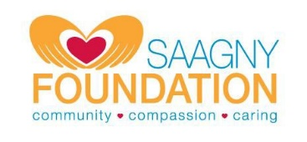
THE SAAGNY FOUNDATION SCHOLARSHIPS –
2022 ACTIVITIES INFORMATION FORM

Please provide information on the following categories. You may submit additional information on a separate sheet if necessary.
Extracurricular Activities: (school clubs, in-school or outside of school teams, etc.)

Community Service / Charitable Activities: (in school and/or outside of school)

Awards / Achievements / Recognition: (academic and/or non-academic)

Outside Jobs / Projects:

This information forms an important part of your application.
Please provide as much information as possible. Attach additional sheets if necessary.

